

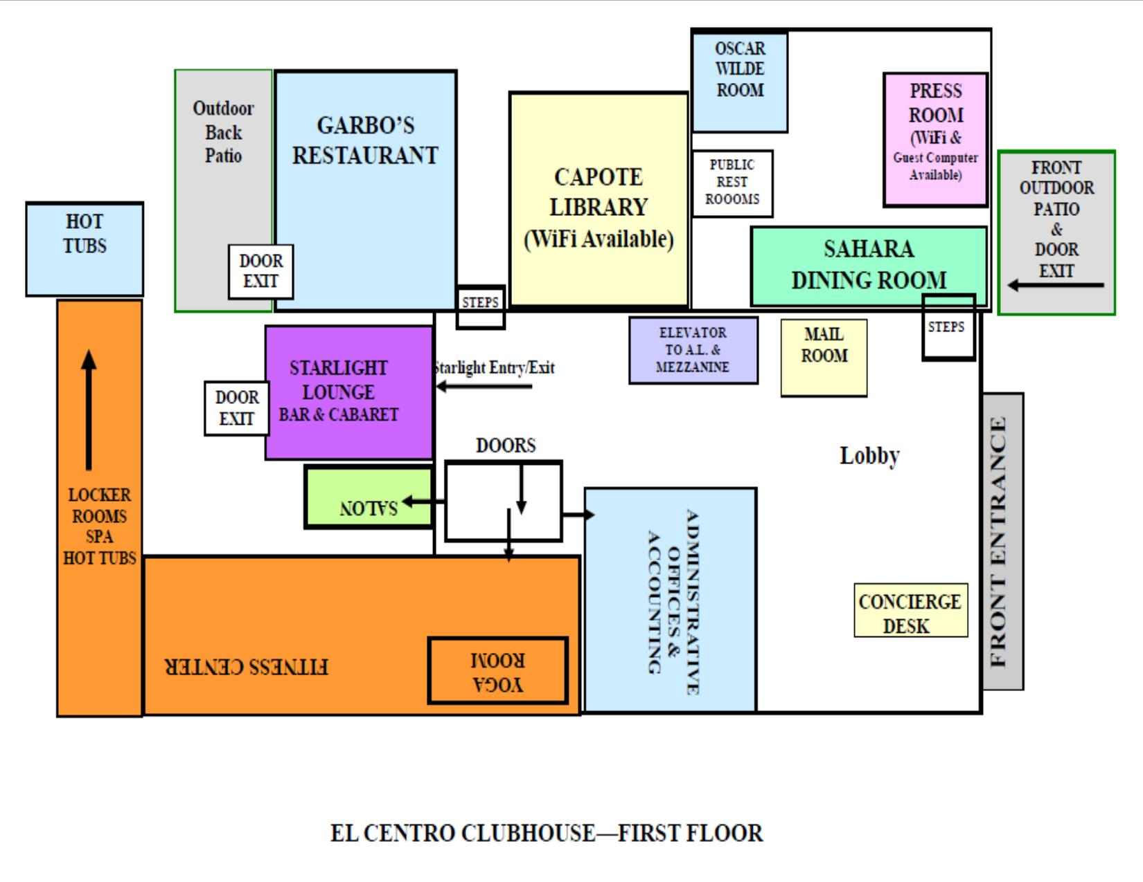

Montecito Santa Fe Concierge Desk

505-428-7777

**Currently the 2nd Floor is open to Assisted Living Community Members ONLY. All others will be stopped at the elevator.**

**Please keep this in mind when selecting activities.**

**Currently the 2nd Floor is open to Assisted Living Community Members ONLY. All others will be stopped at the elevator.**

**Personal Notes & Reminders**

_______________________________________________________

_______________________________________________________

_______________________________________________________

_______________________________________________________

_______________________________________________________

_______________________________________________________

_______________________________________________________

_______________________________________________________

_______________________________________________________

_______________________________________________________

**Activities Suggestions**

_______________________________________________________

______________________________________________________________________________________________________________

_______________________________________________________

_______________________________________________________

_______________________________________________________

_______________________________________________________

_______________________________________________________

_______________________________________________________

_______________________________________________________

_______________________________________________________

_______________________________________________________

_______________________________________________________

**Tuesday, July 6th**

10a-4p Art Studio is Open

9:00a News Room (LS)

11:00a Tai Chi (OW)

1:30p Current Events (OW)

2:30p Green Garden Club (GP)

3:00 Movie: “And So It Goes” (OW)

**Saturday, July 3rd**

9:00a News Room (LS)

10:30a Coffee Chat (S)

1:00p Movie: TBA (OW)

**Sunday, July 4th**

9:00a News Room (LS)

1:00p Ice Cream Social (S)

3:00p Art Hour (AR)

**Monday, July 5th**

10a-4p Art Studio is Open

9:00 News Room (LS)

9:30a Assisted Living Fitness (BJK)

10:15a Independent Living Fitness (GP)

11:00a Tai Chi (OW)

1:00p Community Meeting (OW)

2:00p Green Garden Club (GP)

3:00p Ceramics (AR)

**Friday, July 2nd**

10a-4p Art Studio is Open

9:30a Assisted Living Fitness (BJK)

10:15a Independent Living Fitness (GP)

10:00a Baking Group (DD)

2:00p Know Your Neighbor (OW)

3:00p Happy Hour: Theo Kutsko- Pianist and Vocalist (SL)

**Thursday, July 1st**

10a-4p Art Studio is Open

10:00a News Room (LS)

11:00a Tai Chi (OW)

1:30p Current Events (OW)

3:00p Movie: “Sound of Metal” (OW)

4:00p Green Garden Club (GP)

**Concierge/Front Desk**

505-428-7777 or 505-250-6301 (Cell)

sfconcierge@montecitosantafe.com

**Call the concierge to be directed to any of the departments**

Edgar Ortiz, Executive Director

eortiz@montecitosantafe.com

Linda Krauss, Human Resources Director

lkrauss@montecitosantafe.com

Rachael Hemann, Community Relations

rhemann@montecitosantafe.com

Larry Sweat, Environmental Director

lsweat@montecitosantafe.com

Alma Sosa, Housekeeping Director

asosa@montecitosantafe.com

Cynthia Luna, Lead Concierge

cluna@montecitosantafe.com

Kira Lewis, Chef

klewis@montecitosantafe.com

Lori Rodriguez, Wellness Director

lrodriguez@montecitosantafe.com

Jackie Goerig, Life Enrichment Director

jgoerig@montecitosantafe.com

Scheduling a Van appointment 577-7303

**Monday, July 12th**

10a-4p Art Studio is Open

9:00 News Room (LS)

9:30a Assisted Living Fitness (BJK)

10:15a Independent Living Fitness (GP)

11:00a Tai Chi (OW)

1:00p Community Meeting (OW)

2:00p Green Garden Club (GP)

3:00p Ceramics (AR)

**Friday, July 9th**

10a-4p Art Studio is Open

9:30a Assisted Living Fitness (BJK)

10:15a Independent Living Fitness (GP)

10:00a Baking Group (DD)

1:00p Green Garden Club (GP)

2:00p Happy Hour: “Uke101’s” (GP)

**Sunday, July 11th**

9:00a News Room (LS)

2:00p Movie: TBA

3:00p Art Hour (OW)

**Thursday, July 8th**

10a-4p Art Studio is Open

10:00a News Room (LS)

11:00a Art Hour (AR)

1:30p Current Events (OW)

2:30p Movie: “A Rainy Day in New York” (OW)

4:00p Green Garden Club (GP)

**Saturday, July 10th**

9:00a News Room (LS)

11:00Museum of International Folk Art (RSVP required)

*Bring $7 and ID for NM resident admission, $10 if no proof of NM residence*

**Wednesday, July 7th**

10a-4p Art Studio is Open

9:30a Assisted Living Fitness (BJK)

10:15a Independent Living Fitness (GP)

11:00a Tai Chi (OW)

1:00p Know-Your-Neighbor (OW)

2:00p Green Garden Club (GP)

3:00p Ceramics (AR)

5:00p Scrabble Club (S)

**Saturday, July 17th**

9:00a News Room (LS)

10:00a Scenic Drive (RSVP Required)

2:00p Art Hour (AR)

**Friday**

9:30a Assisted Living Community Fitness (BJK)

10:15 Independent Living Community Fitness (GP)

**Thursday**

9:30a Assisted Living Community Fitness (BJK)

10:15 Independent Living Community Fitness (GP)

**Wednesday**

9:30a Assisted Living Community Fitness (BJK)

10:15 Independent Living Community Fitness (GP)

**Sunday, July 18th**

9:00a News Room (LS)

1:00p Ice Cream Social (S)

3:00p Art Hour (AR)

**Thursday, July 15th**

10a-4p Art Studio is Open

10:00a News Room (LS)

11:00a Art Hour (AR)

1:30p Current Events (OW)

2:30p Movie: “Fried Green Tomatoes” (OW)

4:00p Green Garden Club (GP)

**Wednesday, July 14th**

10a-4p Art Studio is Open

9:30a Assisted Living Fitness (BJK)

10:15a Independent Living Fitness (GP)

11:00a Tai Chi (OW)

1:00p Know-Your-Neighbor (OW)

2:00p Green Garden Club (GP)

3:00p Ceramics (AR)

5:00p Scrabble Club (S)

**Tuesday, July 13th**

10a-4p Art Studio is Open

9:00a News Room (LS)

11:00a Tai Chi (OW)

1:30p Current Events (OW)

2:30p Green Garden Club (GP)

3:00 Movie: “Gulliver’s Travels” (OW)

**Friday, July 16th**

10a-4p Art Studio is Open

9:30a Assisted Living Fitness (BJK)

10:15a Independent Living Fitness (GP)

10:00a Baking Group (DD)

2:00p Know Your Neighbor (OW)

3:00p Carlos Aguirre: Guitarist (SL)

**Monday, July 19th**

10a-4p Art Studio is Open

9:00 News Room (LS)

9:30a Assisted Living Fitness (BJK)

10:15a Independent Living Fitness (GP)

11:00a Tai Chi (OW)

1:00p Community Meeting (OW)

2:00p Green Garden Club (GP)

3:00p Ceramics

**Thursday, July 22nd**

10a-4p Art Studio is Open

10:00a News Room (LS)

11:00a Art Hour (AR)

1:30p Current Events (OW)

2:30p Movie: “Walk the Line” (OW)

4:00p Green Garden Club (GP)

**Tuesday, July 20th**

10a-4p Art Studio is Open

9:00a News Room (LS)

11:00a Tai Chi (OW)

1:30p Current Events (OW)

2:00p Green Garden Club (GP)

2:30 Movie: “The Rocketman” (OW)

**Friday, July 23rd**

10a-4p Art Studio is Open

9:30a Assisted Living Fitness (BJK)

10:15a Independent Living Fitness (GP)

10:00a Baking Group (DD)

2:00p GJ Jazz Duo (SL)

3:30p Know Your Neighbor (OW)

**Wednesday, July 21st**

10a-4p Art Studio is Open

9:30a Assisted Living Fitness (BJK)

10:15a Independent Living Fitness (GP)

11:00a Tai Chi (OW)

1:00p Know-Your-Neighbor (OW)

2:00p Green Garden Club (GP)

3:00p Ceramics (AR)

5:00p Scrabble Club (S)

**Saturday, July 24th**

9:00a News Room (LS)

10:00a (RSVP Required)

2:00p Art Hour (AR)

**Weekly Fitness Schedule**

All Mon/Wed/Fri classes are instructed by Michael Brown.

All Tues/Thurs classes are instructed by Amy Rice.

If you’d like to schedule a personal training session with Michael, please call or email.

[**lifeleticsnm@gmail.com**](mailto:lifeleticsnm@gmail.com) **| (626) 808-7047**

**Monday**

9:30a Assisted Living Community Fitness (BJK)

10:15 Independent Living Community Fitness (GP)

**Tuesday**

9:30a Assisted Living Community Fitness (BJK)

10:15 Independent Living Community Fitness (GP)

**Saturday, July 31st**

9:00a News Room (LS)

10:00a Scenic Drive (RSVP Required)

2:00p Movie: Residents’ Choice (OW)

**July’s Birthdays**

Gloria Guthals–7/1

Pat Carlton –7/2

Edgar Ortiz –7/7

Janie Dimmock –7/7

Jean Palm –7/18

Phyllis Montgomery–7/19

Jeremy Payton –7/20

Jonathan Rubio –7/26

Joan Carroll –7/28

Wayne Friedlander - 7/29

Kira Lewis –7/31

**- If you would like your Birthday to be posted please contact the Activities Department.**

**Dates, Times, and Locations are subject to change.**

**Please contact the Life Enrichment Department at 505-428-7792 if you have any questions or would like to RSVP.**

**Life Enrichment Department News & Reminders**

* All activities in the calendar are for everyone in the community to participate in.
* If you want to sign up for an activities outing, please do so with the Activities Department, not the Concierge. RSVPs are mandatory for the weekend outings.
* If you have an activity idea that you’d like to see on the schedule, please contact Jackie via email. jgoerig@montecitosantafe.com

**Sunday, July 25th**

9:00a News Room (LS)

1:00p Movie: Residents’ Choice (OW)

3:00p Art Hour (AR)

**Wednesday, July 28th**

10a-4p Art Studio is Open

9:30a Assisted Living Fitness (BJK)

10:15a Independent Living Fitness (GP)

11:00a Tai Chi (OW)

1:00p Know-Your-Neighbor (OW)

2:00p Green Garden Club (GP)

3:00p Ceramics (AR)

5:00p Scrabble Club (S)

**Monday, July 26th**

10a-4p Art Studio is Open

9:00 News Room (LS)

9:30a Assisted Living Fitness (BJK)

10:15a Independent Living Fitness (GP)

11:00a Tai Chi (OW)

1:00p Community Meeting (OW)

2:00p Green Garden Club (GP)

3:00p Ceramics

**Thursday, July 29th**

10a-4p Art Studio is Open

10:00a News Room (LS)

11:00a Art Hour (AR)

1:30p Current Events (OW)

2:30p Movie: “Hidden Figures” (OW)

4:00p Green Garden Club (GP)

**Tuesday, July 27th**

10a-4p Art Studio is Open

9:00a News Room (LS)

11:00a Tai Chi (OW)

1:30p Current Events (OW)

2:00 Movie: “All the President’s Men” (OW)

3:00p Green Garden Club (GP)

**Friday, July 30th**

10a-4p Art Studio is Open

9:30a Assisted Living Fitness (BJK)

10:15a Independent Living Fitness (GP)

10:00a Baking Group (DD)

2:00p D’Santi Nava: Flamenco Guitar (SL)

3:30p Know Your Neighbor (OW)